“ StockSmart”
An Inventory Management System for Small and Medium Enterprises

A Project Proposal Submitted to
ACE Institute of Management
In Partial Fulfillment of the Requirements for
Bachelor of Computer Systems and Information Technology (BCSIT)

Submitted by:
Diya Manandhar
Shreyas Regmi
Avash Shrestha
Krishala Pokhrel

Supervised by:
Mr. Sanju Shrestha

Department of Computer Science and Information Technology
ACE Institute of Management
Baneshwor, Kathmandu, Nepal
17th May, 2026

TABLE OF CONTENTS
Chapter 1 Introduction 1
1.1 Background of the Project 1
1.2 Domain Explanation 1
1.3 Context of the Problem 2
Chapter 2 Problem Statement 4
2.1 Defining the Problem 4
2.2 Who Is Affected 4
2.3 Impact of the Problem 5
2.3.1 Stock Shortages 5
2.3.2 Overstocking 5
2.3.3 Expired and Wasted Products 6
2.3.4 Absence of Real-Time Visibility 6
2.3.5 Errors from Manual Record-Keeping 6
User interface Design 9
Products page 9
Inventory page 10
Checkout page 11
Flow Chart 12
Chapter 3 Objectives 13
3.1 Main Objective 13
3.2 Specific Objectives 13
Chapter 4 Methodology 14
Step 1: Requirement Analysis 14
Step 2: Literature Review and Gap Analysis 14
Step 3: System Design 14
Step 4: Feasibility Analysis 15
Step 5: Development and Testing 15
Chapter 5 Feasibility 16
5.1 Technical Feasibility 16
5.2 Operational Feasibility 16
5.3 Economic Feasibility 17
Gantt Chart 18
Project Timeline 18
Task Distribution 19
Avash Shrestha: 19
Diya Manandhar: 19
Krishala Pokharel: 19
Shreyas Regmi: 19
Chapter 6 Expected Outcomes 20
Expected outcomes: 20
1. Development of a fully functional inventory management system. 20
2. Real-time monitoring and updating of stock information. 20
3. Automated low-stock and product expiry alerts. 20
4. Reduction in inventory-related losses and errors. 20
5. Better inventory organization and record management. 20
6. Improved efficiency and productivity for SMEs. 20
7. Affordable and easy-to-use solution suitable for small businesses. 20
Expected Results: 21
1. Improved Inventory Accuracy 21
2. Real-Time Inventory Tracking 21
3. Reduction in Stock Shortages 21
4. Reduced Overstocking 21
5. Better Expiry Management 21
6. Increased Operational Efficiency 21
7. Practical Solution for SMEs 21
Benefits of the Project: 22
1. Easy Inventory Management 22
2. User-Friendly Interface 22
3. Cost-Effective Solution 22
4. Reduced Human Errors 22
5. Better Business Decisions 22
6. Improved Productivity 22
7. Secure and Organized Records 22
Impact of the Project 23
Economic Impact 23
Business Impact 23
Technological Impact 23
Social Impact 23
Educational Impact 23
Conclusion 24
References 25

Chapter 1 Introduction

1.1 Background of the Project
Any business that sells physical goods will eventually have to face the same question: how do you know what you have, and how do you know when you are about to run out? It seems simple enough. But for many small and medium-sized businesses across Nepal and around the world, this question does not have a good answer. Not because the owners do not care, but because the tools available to them have either been too expensive, too complicated, or simply not designed with their kind of business in mind.
Inventory management, at its most basic, refers to keeping track of stock from the time it arrives at a business until it leaves as a sold product. It means knowing how many units of each product are on the shelf, when thenstock is running low, what has expired or is about to expire, and how much was sold over a given period. If done well, it keeps a business running smoothly. If done poorly, or not done at all, it leads to empty shelves, wasted stock, and decisions made on guesswork.
The scale of this problem across the SME sector is difficult to ignore. Industry data shows that 43 percent of small and medium enterprises experience stock-outs every month. That means nearly half of all SMEs are regularly unable to meet customer demand simply because they did not know their stock had dropped that low. Globally, poor inventory control is estimated to cost businesses around USD 1.1 trillion per year. About 30 percent of inventory losses among SMEs come from expired or wasted goods. And two in every three SMEs are still tracking their stock by hand, either on paper or in a basic spreadsheet [1].
Behind each of these numbers is a real business: a shop owner who lost a customer because a product was out of stock, a warehouse manager who discovered an inconsistency during a count that took two days to resolve, a supermarket that had to dispose of a batch of goods that nobody noticed was approaching expiry. StockSmart began as a response to these very real and very common situations.

1.2 Domain Explanation
Inventory management is not a new problem, and it does not look exactly the same across every type of business. The challenges faced by a small grocery shop in Kathmandu are different, at least in their specifics, from those faced by a wholesale distributor or a warehouse. Understanding these differences helped shape what StockSmart needed to do.
Take small retail shops first. Most of them run on thin margins and small teams. The person behind the counter is often also the person doing the ordering, reconciling the stock, and managing supplier relationships. In that context, sitting down to update a spreadsheet at the end of a long day is not always realistic. So things get written on scraps of paper, or committed to memory, and over time the records drift further from reality.
Warehouses are a different story. The volume of goods moving in and out of a warehouse on any given day means that even a small error rate in manual data entry can add up to a significant problem. A wrong quantity recorded here, a missed entry there, and by the time a physical stock count is done, the inconsistency can be substantial. In operations where accuracy directly affects delivery timelines and client relationships, this is not a risk that businesses can afford to take.
Supermarkets deal with a particularly time-sensitive concern: expiry dates. When a product range runs into the hundreds, manually checking shelf dates on a regular basis is both labour-intensive and unreliable. It is the kind of task that falls through the cracks, especially during busy periods. The consequences of getting it wrong range from the financial loss of having to dispose of expired stock, to more serious outcomes involving customer health and regulatory compliance.
Wholesalers face a different kind of pressure. Demand for their products tends to spike seasonally, around festivals, harvests, or weather patterns. Without a system that reflects current stock levels accurately, it becomes very difficult to plan purchases ahead of these spikes. The result tends to be over-ordering when demand is unclear, which ties up cash, or under-ordering, which means turning clients away at exactly the wrong moment.
Across all of these settings, the underlying requirement is the same. Businesses need to know what they have, in real time, without the process of finding out requiring significant time or effort. That is the space StockSmart is designed to occupy.

1.3 Context of the Problem
It would be fair enough to ask, at this point, whether or not there are already made solutions on the market that address these problems. There are. Enterprise Resource Planning systems have been around for decades. IoT-based inventory tracking is a growing field. AI-powered stock forecasting tools are available for those willing to invest in them. So why are two thirds of SMEs still using manual methods?
The answer, put simply, is that these tools were not built for SMEs. ERP systems are designed for medium to large enterprises. Their implementation costs, in terms of licensing fees, hardware requirements, and the time needed to train staff and configure the system, are well beyond what most small businesses can absorb [2]. IoT-based tracking depends on physical infrastructure: sensors, RFID readers, compatible hardware throughout the storage facility. That is a significant upfront investment, and an ongoing maintenance commitment, for a small business that might be operating out of a single room [3]. AI-powered forecasting, while genuinely useful, requires substantial historical data to produce meaningful outputs. A business that has never digitised its inventory records does not have that data, which means it cannot benefit from these tools even if it could afford them [4].
What this points to is a gap. Not a gap in what technology can do, but a gap in what is available at the right cost, the right complexity level, and with the right assumptions about who will be using it. StockSmart was conceived specifically to address that gap.
The system is built on the LAMP stack, which stands for Linux, Apache, MySQL, and PHP. This is a technology combination that has been in active use for well over two decades, is thoroughly documented, and carries no licensing fees. The backend framework is Laravel, a PHP framework that simplifies the development of structured web applications and provides built-in support for the kind of database operations that inventory management requires. Businesses that have access to even modest technical support can host the system on their own hardware, which eliminates subscription costs entirely.
The aim of StockSmart is not to replicate what enterprise software already does for large organisations. It is to take the specific, practical needs of small and medium enterprises and build something that addresses those needs directly, without unnecessary complexity, and without a price tag that puts it out of reach.

Chapter 2 Problem Statement

2.1 Defining the Problem
Many small and medium businesses today operate without a clear picture of their own inventory. They may have a rough sense of what is on the shelf, shaped by experience and habit, but that is not the same as knowing. And when business decisions, from reordering to pricing to managing waste, depend on knowing what is actually in stock, that difference matters more than it might appear.
The core issue is this: SMEs lack access to a system that gives them accurate, up-to-date inventory information in a form that is simple to use and affordable to run. In the absence of such a system, they default to manual methods, each with their own failure modes. Paper records get lost or damaged. Spreadsheets are only as current as the last person who updated them. Memory is unreliable, especially when a business grows or staff changes.
These are not isolated incidents. They are the expected outcomes of managing inventory without a proper system. The problems that follow, from unexpected shortages to overfilled storerooms to products quietly expiring on a shelf, are predictable consequences of that original gap. And because they tend to happen gradually, they can go unnoticed until the financial damage is already done.

2.2 Who Is Affected
The businesses most affected by inadequate inventory management are those that deal in physical goods, have limited administrative resources, and cannot absorb the kinds of losses that poor stock control produces. In practice, that covers a wide range of SMEs.
- Small retail shops and convenience stores carry the full burden of stock management with very little support. There is no dedicated inventory team, no automated reorder system, and often no clear separation between the person selling and the person managing stock. Accurate manual record-keeping in that environment is difficult to sustain consistently.
- Warehouses that handle large and varied product ranges face a different problem. The absolute volume of goods moving through a warehouse means that manual tracking is not just inconvenient but genuinely unreliable. Errors that would be minor in a small shop compound quickly at warehouse scale.
- Supermarkets and grocery stores have the additional pressure of managing perishable goods. Expiry date oversight is not just a financial concern; it has direct implications for customer safety and regulatory compliance. Manual checks, however conscientious, are not a dependable safeguard at scale.
- Wholesale distributors must plan their stock levels around demand patterns that shift with seasons and events. Without reliable inventory data, that planning becomes guesswork, and the consequences of guessing wrong, whether that means unsold stock or unfulfilled orders, are felt directly in the business's bottom line.

The effects of these problems also extend to customers. When a business runs out of stock, the customer goes without. When expired goods reach the shelf, the customer is the one put at risk. Poor inventory management is ultimately a failure that travels all the way through the supply chain to the person on the other end.

2.3 Impact of the Problem
The consequences of not managing inventory properly tend to fall into five recurring patterns. Each one is worth examining in some detail, because together they illustrate why this problem, though it might seem mundane, carries significant costs.

2.3.1 Stock Shortages
A stock shortage happens when a business runs out of a product that a customer wants to buy. In a well-managed system, that should rarely happen, because low stock levels trigger a reorder before the shelf empties. In a business relying on manual tracking, that early warning often does not come. The shop owner finds out the product is gone when a customer asks for it. That is a lost sale. If it happens regularly with the same product, it is also a lost customer. Around 43 percent of SMEs face this situation on a monthly basis [1], which means it is not an edge case but a recurring cost of doing business without proper inventory tools.

2.3.2 Overstocking
The natural response to worrying about running out of stock is to order more than necessary. Without reliable data on what is actually selling and at what rate, businesses err on the side of excess. The result is stock that sits in storage for longer than it should, tying up money that the business might need elsewhere. For perishable goods, excess stock also becomes a direct waste problem. For non-perishables, it is simply capital that is not working. Either way, overstocking is a cost that could be avoided with better information.

2.3.3 Expired and Wasted Products
This is perhaps the most visible failure of manual inventory management. When there is no system flagging that a product is approaching its expiry date, that product often stays on the shelf or in storage until someone checks it manually, and by then it may already be too late. The loss is direct: the business paid for that stock and cannot sell it. For food, pharmaceutical, or cosmetics retailers, the implications go beyond financial loss and into the territory of customer safety and legal liability. Around 30 percent of SME inventory losses are attributed to this problem [1], which makes it one of the more significant and preventable drains on business resources.

2.3.4 Absence of Real-Time Visibility
A ledger updated once a day, or a spreadsheet filled in at the end of a shift, cannot tell one what their current stock position is. It can only tell one what it was at the time of the last update. For a business making purchasing decisions, that distinction matters. Orders placed on outdated information can result in either shortfalls or excess, because the actual situation has moved on since the records were last touched. This is an inherent limitation of any system that is not updated as transactions happen, and it is one of the primary reasons why real-time tracking is a non-negotiable feature in a system designed to genuinely help businesses manage their inventory.

2.3.5 Errors from Manual Record-Keeping
Manual data entry introduces errors. This is not a criticism of the people doing it; it is simply a characteristic of any process that relies on humans transcribing information repeatedly. A quantity written down incorrectly, a product entered under the wrong category, a delivery recorded as received when part of it was not, these kinds of mistakes are easy to make and difficult to spot until they cause a visible problem. Over time, they accumulate. The record diverges from reality. A digital system that records transactions at the point they occur removes most of the conditions that make these errors possible.

Each of the five problems above is well-known among SME owners. These are workarounds for a problem that has a more direct solution. StockSmart is proposed as that solution: a system built to address these specific failure points, designed for the businesses most affected by them, and priced in a way that does not add another burden to the ones they are already managing.
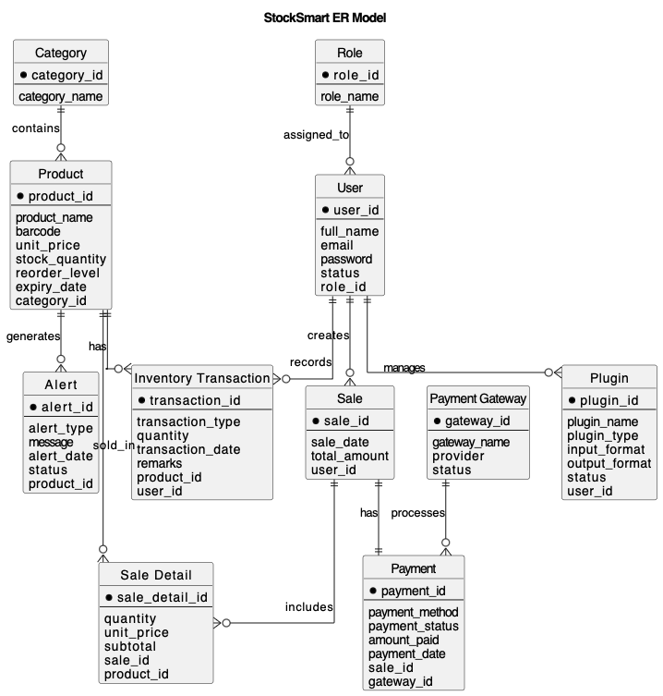

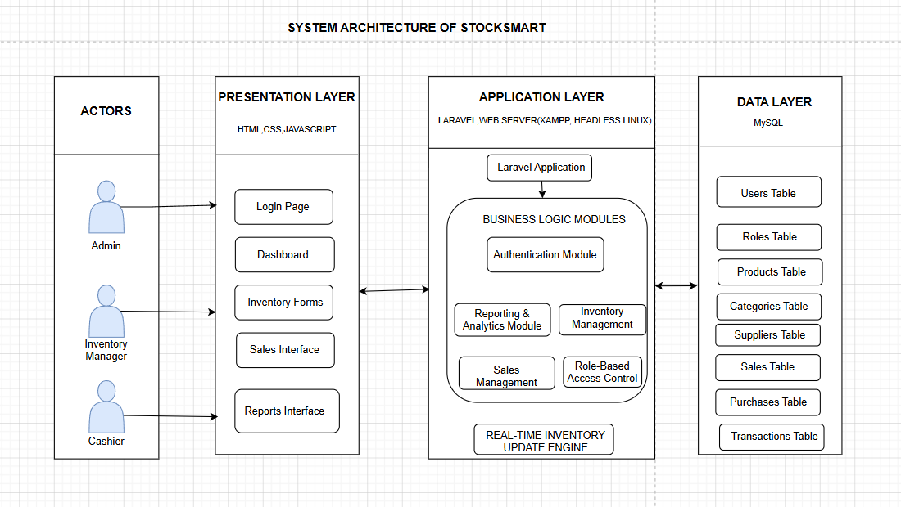

User interface Design

Products page
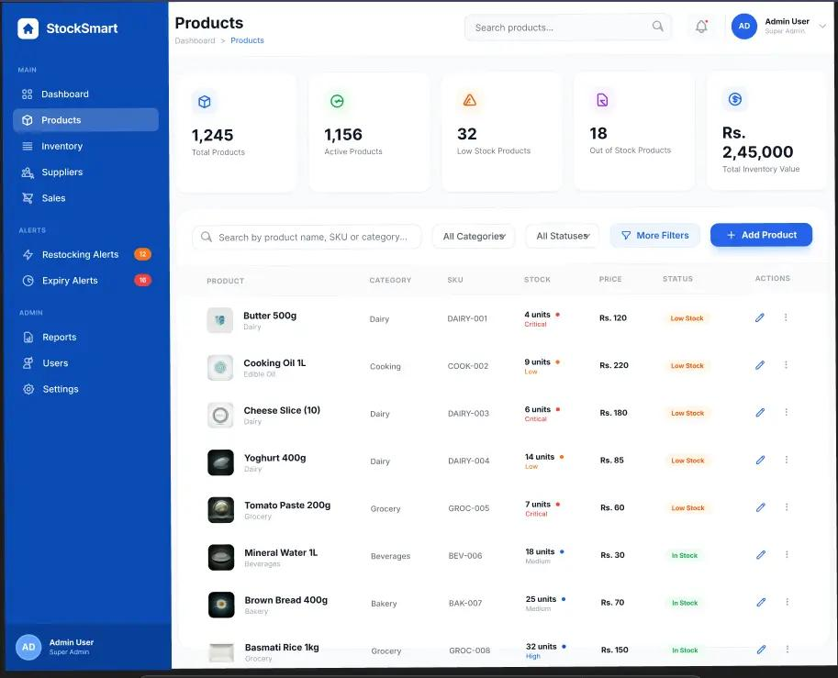

This product display page was designed in Figma and serves as the main interface for managing inventory products. It provides a clear overview of key inventory statistics, including total products, active products, low-stock items, and total inventory value. Users can easily search, filter, and manage products through an organized and user-friendly layout. The product table displays important details such as product name, category, SKU, stock level, price, and status. Overall, the page enhances inventory management by providing quick access to product information and administrative actions.

Inventory page

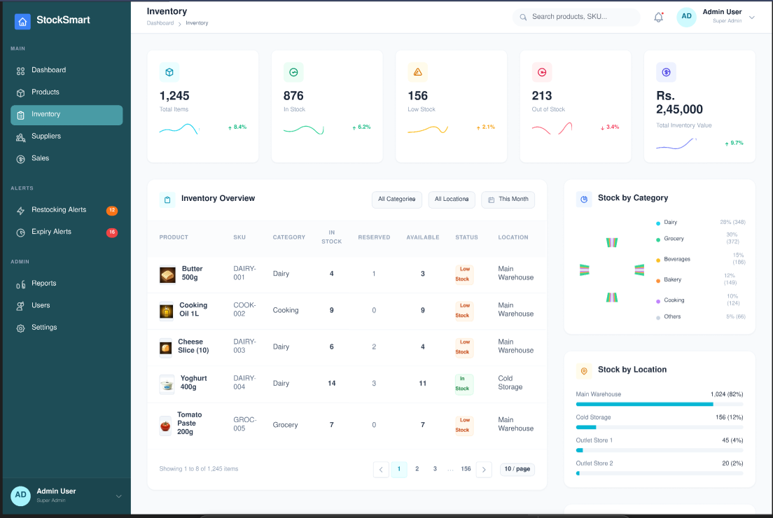

This inventory page was designed in Figma and serves as the central hub for monitoring and managing inventory across different locations. It provides a quick overview of key inventory metrics, including total items, items in stock, low-stock products, out-of-stock products, and total inventory value. The page features an inventory overview table displaying product details, stock availability, reserved quantities, and storage locations. Visual charts and graphs help users analyze stock distribution by category and location for better decision-making. Overall, the interface offers an organized and efficient way to track inventory levels and maintain stock control.

Checkout page

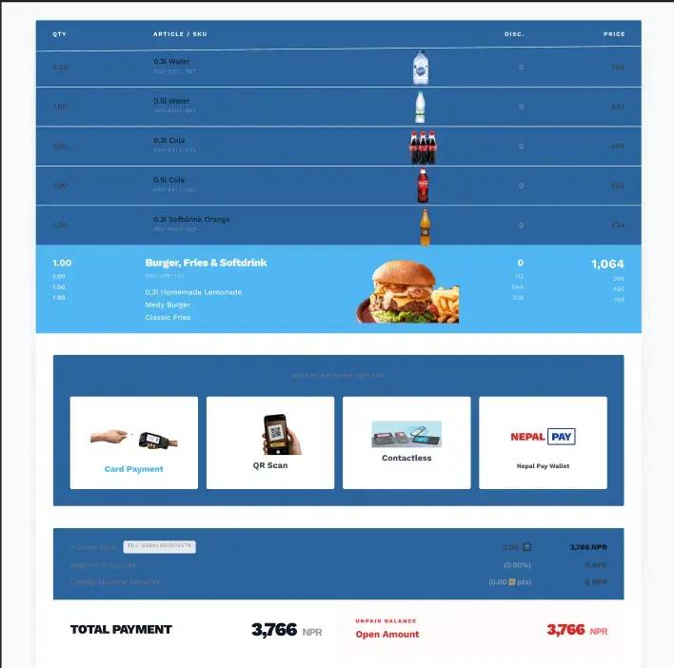

This checkout page was designed in Figma to provide a smooth and efficient point-of-sale experience. It displays a detailed summary of selected products, including quantities, item descriptions, discounts, and total prices. Multiple payment options, such as card payment, QR scan, contactless payment, and digital wallets, are available to offer flexibility to customers. The page also presents billing information, payment status, and the final amount due in a clear and organized format. Overall, the interface ensures a fast, user-friendly, and secure checkout process for both customers and staff.

Flow Chart

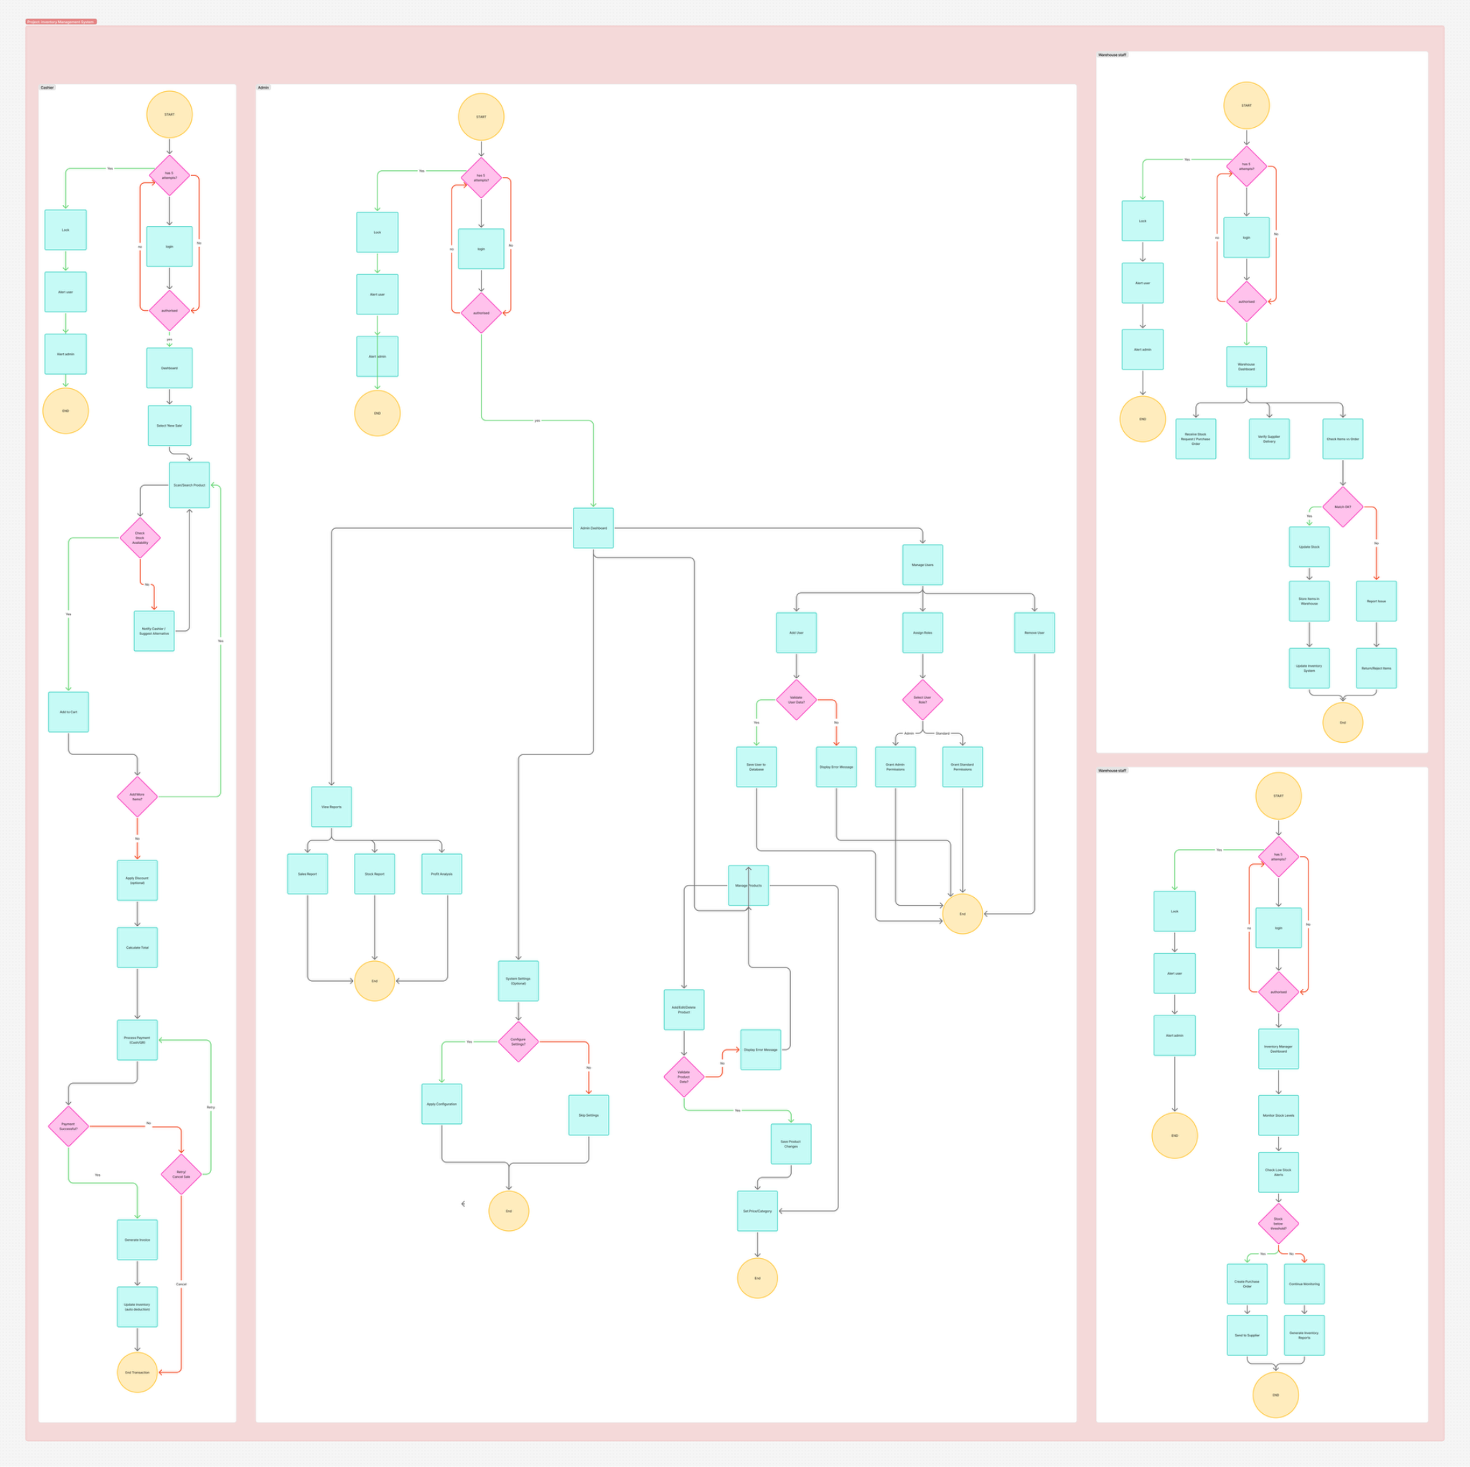

Chapter 3 Objectives
This section presents the objectives that guide the design and development of StockSmart. The objectives define the intended outcomes of the system and serve as measurable benchmarks for evaluating its success upon completion.

3.1 Main Objective
The main objective of this project is to design and develop StockSmart, a simple and centralized web-based inventory management system for small and medium-sized enterprises (SMEs). The system aims to enable real-time inventory tracking, automate stock-related alerts, and streamline transaction recording so that businesses can reduce inventory losses and improve their overall operational efficiency.

3.2 Specific Objectives
In order to achieve the main objective stated above, the following specific objectives have been identified:

- To develop a real-time inventory tracking module that allows authorized users to monitor current stock levels and record all stock-in and stock-out transactions accurately and efficiently.
- To implement an automated low stock alert system that notifies relevant users when product quantities fall below a predefined minimum threshold, enabling timely restocking decisions.
- To develop an automated expiry date monitoring system that tracks the expiry dates of perishable products and generates alerts before products expire, thereby reducing losses from expired or wasted goods.
- To reduce financial losses caused by overstocking, stock shortages, and the disposal of expired products by providing management tools that support more informed and proactive inventory decisions.
- To improve the accuracy and operational efficiency of inventory management by replacing manual processes with an automated, centralized system that minimizes human error and reduces the time spent on routine inventory tasks.
- To lower operational overhead costs for SMEs through automation, self-hosted deployment, and the use of open-source technologies, making the system accessible to businesses with limited financial resources.

Chapter 4 Methodology
The development of StockSmart follows a structured and sequential methodology consisting of five steps: Requirement Analysis, Literature Review and Gap Analysis, System Design, Feasibility Analysis, and Development and Testing. Each step builds upon the findings of the previous one to ensure that the final system is well-grounded, practically viable, and aligned with the actual needs of its target users.

Step 1: Requirement Analysis
The first step of the methodology involves a thorough analysis of the inventory-related challenges commonly faced by small and medium-sized enterprises. This includes examining problems arising from manual inventory practices, such as inaccurate stock counts, delayed responses to stockouts, and the absence of structured monitoring for product expiry. Based on this analysis, the key functional requirements of StockSmart are identified. These requirements cover core features such as real-time stock tracking, transaction recording, alert generation, user role management, and report generation. The outcome of this step provides a clear and agreed-upon foundation for all subsequent design and development work.

Step 2: Literature Review and Gap Analysis
The second step involves a review of four existing inventory management systems currently available in the market. The purpose of this review is to understand the features and capabilities that existing solutions offer, as well as the limitations they present, particularly in the context of SMEs. Following the review, a gap analysis is conducted to identify features that are absent or inadequately addressed in current solutions, such as expiry date monitoring, affordable self-hosting options, and role-based access tailored to small business operations. The findings of this step directly inform the design decisions made for StockSmart, ensuring that the system addresses real and documented gaps rather than duplicating what already exists.

Step 3: System Design
In the third step, the overall structure of StockSmart is designed before any coding begins. This includes the design of the database schema, which defines how data such as product information, transaction records, and user details are stored and related to one another. User flow diagrams are created to map out how different types of users, namely the Admin, Inventory Manager, and Cashier, navigate and interact with the system. User interface wireframes are also developed to plan the layout and visual structure of each screen. Additionally, the core modules of the system are defined at this stage, including the Inventory module, Alert module, Dashboard, and Reports module. This design phase ensures that the system is well-organized and that all components are planned coherently before implementation begins.

Step 4: Feasibility Analysis
Before proceeding to development, a feasibility analysis is conducted to confirm that the project is achievable within the given constraints of time, skill, and resources. The analysis evaluates the project from three perspectives: technical feasibility, which assesses whether the required technologies and technical knowledge are available; operational feasibility, which considers whether the system can be realistically used by its intended users in a day-to-day business environment; and economic feasibility, which examines whether the system can be developed and maintained without placing an excessive financial burden on the development team or the end users. The findings of this step are discussed in detail in Section 6 of this report.

Step 5: Development and Testing
The final step involves the actual construction and evaluation of the StockSmart system. Development is carried out module by module, following the design specifications established in Step 3. Once each module is built, it undergoes individual testing to verify that it functions correctly and meets the requirements identified in Step 1. After all modules are integrated, the complete system is tested for overall performance, accuracy, and reliability. Validation is carried out using sample data derived from realistic SME scenarios to ensure that the system behaves as expected under conditions that reflect its intended use environment. Any issues identified during testing are addressed before the system is considered complete.

Chapter 5 Feasibility

A feasibility study was conducted to determine whether StockSmart can be successfully developed and deployed within the scope of this project. The analysis is divided into three distinct areas: technical feasibility, operational feasibility, and economic feasibility. Each area is examined separately to provide a comprehensive assessment of the project's viability.

5.1 Technical Feasibility
Technical feasibility refers to whether the project can be built using available technologies and within the technical capabilities of the development team. StockSmart will be developed using a well-established and widely documented technology stack. All selected technologies are supported by extensive official documentation, active developer communities, and a proven track record of use in similar systems. The development team already possesses practical knowledge of a significant portion of this stack, reducing the risk of major technical obstacles during development. Where new tools or libraries are required, they are mature and well-supported, with readily available learning resources. Additionally, the overall scope of the system is appropriate for an SME-focused solution, meaning the implementation does not require unnecessarily complex infrastructure. Supporting functionalities such as alert notifications and report generation will be handled using established libraries and APIs, further reducing development complexity. On this basis, the project is considered technically feasible.

5.2 Operational Feasibility
Operational feasibility refers to whether the system can realistically function within the day-to-day operations of an SME and be used effectively by its intended users. StockSmart is designed with simplicity and ease of use as central priorities. The user interface will be straightforward and intuitive, requiring minimal technical training for staff to operate it confidently. Role-based access ensures that each user type, whether Admin, Inventory Manager, or Cashier, interacts only with the features relevant to their responsibilities, reducing the risk of errors and unnecessary complexity. Automated alerts for low stock and product expiry remove the need for constant manual monitoring, which directly lowers the operational effort required from staff. Furthermore, the planned integration with electronic paper-based price labels offers additional operational benefits for clients by enabling automatic price updates, which reduces manual labelling tasks and associated labour costs. The system is therefore considered operationally feasible.

5.3 Economic Feasibility
Economic feasibility refers to whether the system can be developed and maintained without incurring costs that are prohibitive for either the development team or the end users. StockSmart is built entirely using open-source software, which eliminates all software licensing fees. The system is designed to be self-hosted on the client's own hardware or local network, removing the need for paid cloud hosting services, a virtual private server (VPS), a public IP address, or an external domain. This significantly reduces the ongoing operational costs that a business would typically incur when using a cloud-dependent system. For SMEs with sufficient technical capability, the open-source nature of the software means the system can be deployed and managed at virtually no additional cost. Payment processing functionality, where applicable, will be implemented using free and open-source tools, keeping transactional overheads minimal. Post-deployment maintenance will be carried out by the development team until the system is stable and all identified issues are resolved, ensuring that clients are not left without support after handover. Based on these considerations, the project is confirmed to be economically feasible, particularly for SMEs operating with limited budgets.

Gantt Chart

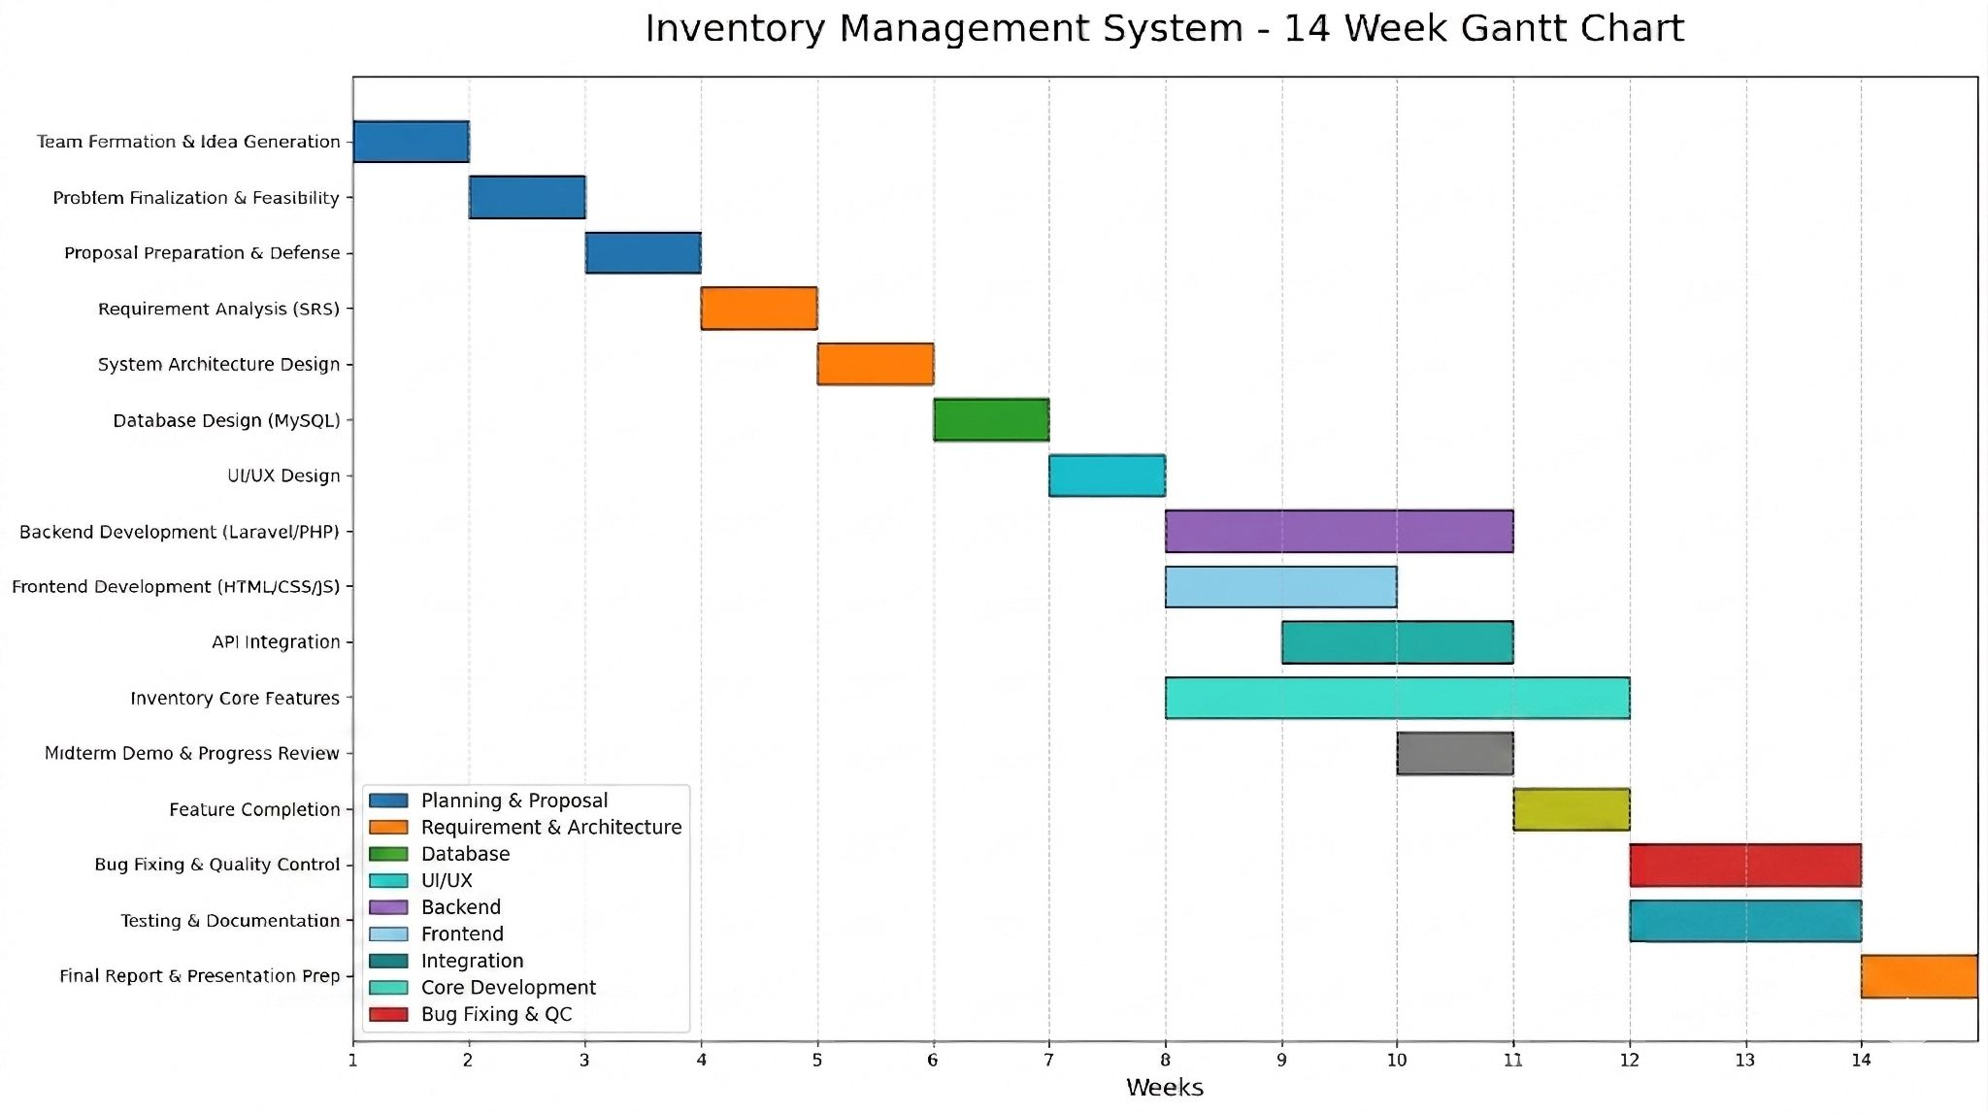
Project Timeline

Task Distribution

Avash Shrestha:
Frontend and Requirement analysis

Diya Manandhar:
Backend and Planning

Krishala Pokharel:
Documentation, QC and Debugging

Shreyas Regmi:
Database, UI/UX design, Integration

Chapter 6 Expected Outcomes
The expected outcome of the StockSmart project is the development of a smart, reliable, and user-friendly inventory management system specially designed for Small and Medium Enterprises (SMEs). The system is
expected to help businesses manage inventory efficiently by providing real-time stock tracking, automated
alerts, and organized inventory records. StockSmart aims to replace traditional paper-based and spreadsheet-based inventory methods with a centralized digital platform that improves accuracy, reduces operational errors, and increases overall business efficiency. The project has the following expected outcomes:

Expected outcomes:

Development of a fully functional inventory management system.

Real-time monitoring and updating of stock information.

Automated low-stock and product expiry alerts.

Reduction in inventory-related losses and errors.

Better inventory organization and record management.

Improved efficiency and productivity for SMEs.

Affordable and easy-to-use solution suitable for small businesses.

Expected Results:

After the successful completion of the StockSmart project, the following results are expected:

1. Improved Inventory Accuracy
The system will reduce manual recording errors and provide more accurate stock information.

2. Real-Time Inventory Tracking

Businesses will be able to monitor stock levels instantly, helping them make better inventory decisions.

3. Reduction in Stock Shortages
The automated alert system will notify users about low stock levels, helping businesses avoid product
Shortages.

4. Reduced Overstocking
StockSmart will help businesses maintain balanced inventory levels, reducing unnecessary storage costs.

5. Better Expiry Management
The system will help track product expiry dates and reduce losses caused by expired products.

6. Increased Operational Efficiency
Businesses will save time and effort by automating inventory-related tasks and maintaining organized digital
Records.

7. Practical Solution for SMEs
The project will provide a practical and affordable inventory solution suitable for small shops, supermarkets,
warehouses, and wholesalers.

Benefits of the Project:

The StockSmart project provides several important benefits to businesses and SMEs.

1. Easy Inventory Management
The system simplifies stock handling and inventory management processes.

2. User-Friendly Interface
The platform is designed to be simple and easy to understand for all users.

3. Cost-Effective Solution
StockSmart is more affordable compared to complex ERP and AI-based inventory systems.

4. Reduced Human Errors
Digital inventory records minimize mistakes caused by manual record keeping.

5. Better Business Decisions
Real-time stock information helps businesses make better purchasing and inventory decisions.

6. Improved Productivity
Automated inventory processes reduce workload and improve operational efficiency.

7. Secure and Organized Records
The system helps maintain organized and secure inventory data.

Impact of the Project
The StockSmart project is expected to create positive impacts on businesses, SMEs, and inventory
management systems.

Economic Impact
● Reduces financial losses caused by overstocking and expired products.
● Helps businesses reduce operational and storage costs.
● Provides an affordable inventory management solution for SMEs.

Business Impact
● Improves inventory monitoring and stock management.
● Increases efficiency in business operations.
● Enhances customer satisfaction by reducing stock shortages.

Technological Impact
● Encourages SMEs to adopt digital inventory systems.
● Replaces outdated paper-based inventory methods.
● Demonstrates the practical use of software solutions in business management.

Social Impact
● Supports small businesses by improving their operational capabilities.
● Helps create more organized and efficient workplaces.
● Promotes awareness of smart business technologies.

Educational Impact
● Provides students and developers with practical experience in software development and inventory
management systems.
● Demonstrates real-world application of database management and web technologies.

Conclusion

StockSmart is expected to become a simple, efficient, and affordable inventory management system for
SMEs. The project focuses on solving common inventory problems such as stock shortages, overstocking,
expired products, and manual record errors.
By providing real-time inventory tracking, automated alerts, and organized digital records, StockSmart can
help businesses improve efficiency, reduce operational costs, and make better inventory decisions.
The expected outcomes, benefits, and impacts of the project demonstrate that StockSmart has strong
practical value and real-world business applications. With its affordable implementation and user-friendly
design, the project can become an effective solution for modern inventory management.

References

Books and Journals
1. Agboola, F. F., Malgwi, Y. M., Mahmud, M. A., & Oguntoye, J. P. (2022). Development of a web-
based platform for automating inventory management of SMEs.
2. Qureshi, M. R. N. M. (2022). Evaluating enterprise resource planning (ERP) implementation for
sustainable supply chain management.
3. 4. 5. 6. Haider, G., & Lucas, E. (2024). Smart inventory management for SMEs using IoT and automation.
Abdul Majid, K., & Kavyashree, G. J. (2025). Smart inventory and sales analytics for supermarkets.
Sommerville, I. (2016). Software Engineering (10th ed.). Pearson.
Pressman, R. S., & Maxim, B. R. (2020). Software Engineering: A Practitioner’s Approach (9th ed.).
McGraw-Hill.
7. Laudon, K. C., & Laudon, J. P. (2021). Management Information Systems: Managing the Digital
Firm. Pearson.

